Fall 2023 Annual Update Program and Area Review (PAR):
Deans/VP Summary Report

Dear Deans/VPs,

This template will help you to prepare to fill in your Deans/VP Summary Report in Qualtrics. We do not recommend entering data directly into Qualtrics without having it saved in this template because we fear the Qualtrics server could have a glitch and you could lose your work. However, this template is just a worksheet; make sure to enter your final responses into Qualtrics.

Please reach out to the PAR Tri-Chairs if you have any questions:
Brian Goo bgoo@chabotcollege.edu, Na Liu nliu@chabotcollege.edu, and Simon Abramowitsch
sabramowitsch@chabotcollege.edu.

Background Information
- Name of Your Area/Division:
- Your Name:
Campus-Wide Issues
- Programs in your division/area were asked to rank the seven recommendations PRAC put forward. Please review your “Summary Data Report” from Qualtrics (these reports aggregate all responses from programs in your division/area). Based on their responses and your own experiences, in ranked order, what do you believe are the top 3-5 campus-wide issues that deserve immediate attention?

Service Area Outcomes
- Are there any programs/services/areas with service area outcomes in your division/area?
☐ Yes
☐ No
- Please refer to your Summary Data Report from Qualtrics. Service areas were asked the status of their SAO assessments. Have all service areas within your division/area assessed two SAOs in the past five years, in which assessments included plans for continuous improvement?
☐ Yes
☐ No
☐ NA

Note: To directly look up a service area’s SAO assessment results, use this SAO 2022 Assessment Update SPREADSHEET*
*If the URL does not open, try copy-pasting the link below into a web browser: https://docs.google.com/spreadsheets/d/1-NEEF-ObcGBiuHKYuUMmar7rqAGlIQLn/edit#gid=534718710
- If not, by when do you believe you can support the service areas in your division/area with filling out the SAO 2023 Assessment Updates Survey in Qualtrics?

Learning Outcomes Assessment Results
Please refer to your Summary Data Report from Qualtrics and the SLO Assessment Report* to answer the following questions.
*If link does not open, try copy-pasting: https://docs.google.com/spreadsheets/d/1iI63NICLx_ikwo6xe3m14riEFO6qJT1huO91v_o8lGs/edit#gid=0
- Are there any programs/services/areas with student learning outcomes (SLOs) in your division/area?
☐ Yes
☐ No

- Is assessment for all SLOs in your division/area up to date?
☐ Yes
☐ No
☐ NA

- If not, by when do you anticipate being able to support faculty in your division/area with completing this process? (Or for VPs, how will you support the Deans to get this task completed?) Do you have concerns you would like to share?

Please refer to your Summary Data Report from Qualtrics and the PLO Assessment Completion Report* to see how many Certificate and Degree Programs in your division assessed PLOs in the 5-year cycle. Programs who did not submit a complete PLO assessment are highlighted in pink.

*If link does not open, try copy-pasting: https://docs.google.com/spreadsheets/d/1UcfTCXMMU06JJgQPWiTDnm7km-5g14hV4hvhA8lOUfo/edit?usp=sharing
- Is assessment for all PLOs in your division/area up to date?
☐ Yes
☐ No
☐ NA

- If not, by when do you anticipate being able to support faculty in your division/area with completing this process? (Or for VPs, how will you support the Deans to get this task completed?) Do you have concerns you would like to share?

Reflections on Goals & Future Planning
Context: In their Fall 2021 PARs, programs in your division/area established goals to support continuous improvement in SLOs, PLOs, SAOs, meeting the college mission, or mission critical priorities in the Educational Master Plan. Please review the Summary Data Report to see how programs in your division/area responded to the question: what is going well and what are some challenges regarding completing your programs/area’s goals?

- What trends in their accomplishments stand out regarding completing your program’/area’s goals?

- What trends regarding challenges stand out regarding completing your program’/area’s goals?

Program Maps

- Have all program maps been updated in your division/area?
☐ Yes
☐ No
☐ NA

- If not, by when do you believe you can support the programs in your division/area in completing their maps? Please share the Review Your Program Map document and Program Map Review Feedback form with faculty in your area to provide updates for maps. If faculty members need support to update program maps, they can reach out to Heather Oshiro hoshiro@chabotcollege.edu.

Summary Analysis

- Please provide a summary of your division’s/area’s key contributions/major achievements since the Fall 2022 Update Year PAR. (300 words)

- Please provide a summary of your division’s/area’s greatest challenges since the last Fall 2022 Update Year PAR. (300 words)

Goals and Resource Requests for Your own Division’s/VP’s Office
Context: Your office also established goals, please look at this sheet* to see the goals that you first established in Fall 2021 and updated or confirmed in Fall 2022.
*If link does not open, try copy-pasting the link below into a web browser: https://docs.google.com/spreadsheets/d/1rLHCG6KcA6Dl1JecmsHf8RyxVzCqS1nNb9Se7Zjnd6E/edit#gid=0

- So far, what is going well regarding completing your office’s goals? Please include reflections on achievement of outputs or outcomes.

- What are some challenges regarding completing your office’s goals? Please include reflections on challenges with producing outputs or outcomes so far.

*Note: if you need to amend one of your office’s PAR goals, please email the adapted goals to Na Liu nliu@chabotcollege.edu

Context: You will need to enter resource requests for your own division’s/VP’s offices into Fall 2023 Resource Request Submissions.

- How do these requests support the goals in your division/area?

Instructions for Resource Requests from Programs in Your Division/Area
- Deans, please follow the instructions below for resource requests from your division.
- VPs, please also visit the dashboard. For any requests from programs reporting directly to you (i.e., not from the Deans’ divisions), please follow these same instructions.
- You need to clean-up, analyze, and rate resource requests from your area, to support funding decisions at the college.
- You will do this in the Fall 2023 Resource Request Dashboard*
* If link does not open, try copy-pasting the link below into a web browser: https://clpccdorg.sharepoint.com/:l:/s/IRChabot/FO5fK9PX_vNNr0jMb1_j6TMBgR21F2EEypel47xVYXTvaw

Cognito Forms Dashboard: Resource Request Instructions
Note: You are only responsible to do the following items for resource requests made by programs/areas you manage.
- To edit the dashboard, click “edit in grid view."
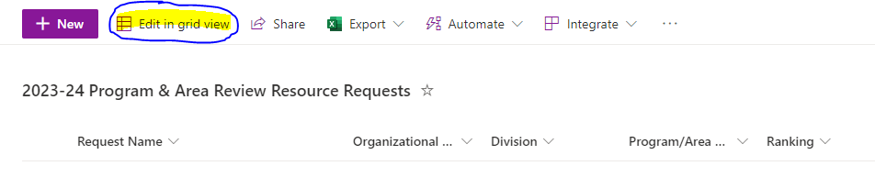
- First: Make sure you can find the requests for your Organizational Unit and Division.
  - You can filter the list by clicking on the Organizational Unit or Division columns and selecting “Filter by”
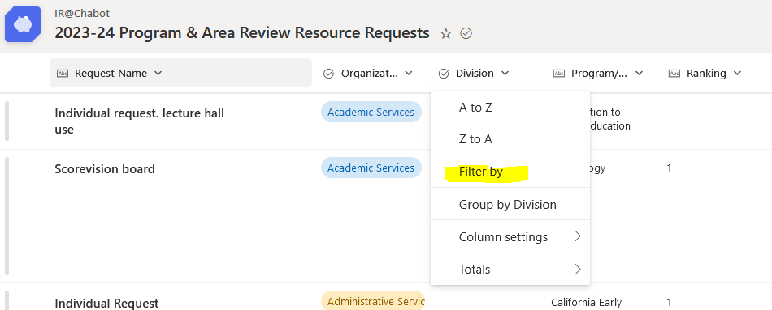
- Second: Make sure requests are categorized correctly.
    - Student tutors/student employees should be requested under “Human Resources”
    - Professional organization memberships should be requested under “Contracts and Services”
    - Items relating to professional development should be requested under “Professional Development.”
    - Computers and other technology hardware should be requested under “Technology” rather than “Equipment.”
    - Software should be requested under “Supplies and Software” NOT under “Technology”
- Third: In the column “Already/will be funded?”, mark “Yes” for requests that are already or you know will be:
    - funded by base allocations,
    - funded by a source about which Deans can make internal decisions and you plan to fund,
    - funded yearly,
    - funded through the facilities master plan (mostly for facilities requests), and/or,
    - funded for any other reason.
  - If you are not recommending the request for other funding sources (Step 4) or for committee review (step 5) mark the request as “No”
- Fourth: In the column “Potential Funding Source,” identify and enter potential funding sources
  - Go through requests for your area to identify potential funding source(s) for the request (e.g., Strong Workforce, Guided Pathways, SEA, Professional Development, General Fund, IST, FIT, etc.). These could be requests that may be funded out of base allocation but you want to see if they can be funded by external/categorical funds first.
    - In the column “Requestor Possible Funding” the area filling out the resource request has indicated what funding could potentially be used to fund this request. However, only your assessment will be used to forward requests to committees or other funding areas.
    - Sometimes, the category under which something is requested is not the most applicable funding source. For example, a CTE faculty needing training on a piece of equipment might request under the professional development category, but that could be funded by Strong Workforce.
- Fifth: In the column “Needing Committee Review,” identify which Shared Governance committees need to review these requests
  - Go through requests in your area to identify requests that should go to shared governance committees for review. This could be for requests you plan on funding out of your base allocation or have a funding source already identified. This could also be used for requests that are not currently funded and could be funded by committees with budgetary control.
  - Common situations:
    - IST (Instructional & Services Technology) - A technology request that is either not funded or is a new technology that may need ongoing support from ITS
    - FIT (Facilities & Infrastructure Technology) - A facilities request that should be planned for in the future (i.e. in the Facilities Master Plan) or the creation of a new space
    - CE (Career Education) - Requests that could possibly be funded by Strong Workforce, Perkins, or other Career Education funds
    - SASE (Student Access, Success & Equity) - Requests that could be funded by Student Equity and Success funds

- Sixth: Deans’/VPs’ Resource Request Assessment
  - For requests that could potentially be funded through external sources or are being sent to shared governance committees, Deans and VPs are being asked to assess the requests to assist potential funders or committees prioritize requests from multiple areas.
  - Your assessment is intended to provide your birds eye view and expertise on programs in your division/area to shared governance committees to assist them in their funding recommendations.

Resource Request Assessment Rubric
 | Criteria
Crucial | This resource request must be funded, or a program/service area crucial component will not be able to be effectively delivered.
Very important | This resource request supports delivery of program/service area component that has demonstrated efficacy for improving students' experiences with campus interfaces, services, and/or instruction (i.e., efficacy for increasing enrollment, persistence, success, and/or completion).
Important | This resource request is innovative and promising, but evidence is still under development to illustrate it will improve students' experiences with campus interfaces, services, and instruction.
Documenting Need | This resource request is not expected to be funded this year, but is being forwarded to funding sources or shared governance committees for future planning purposes.

